Объединение таблицы с архивной, используя динамическое партиционирование.

Пример с ресурса:

<https://docs.microsoft.com/ru-ru/azure/hdinsight/hdinsight-hadoop-optimize-hive-query>:

SET hive.exec.dynamic.partition = true;

SET hive.exec.dynamic.partition.mode = nonstrict;

INSERT INTO TABLE lineitem_part

PARTITION (L_SHIPDATE)

SELECT L_ORDERKEY as L_ORDERKEY, L_PARTKEY as L_PARTKEY , L_SUPPKEY as L_SUPPKEY, L_LINENUMBER as L_LINENUMBER, L_QUANTITY as L_QUANTITY, L_EXTENDEDPRICE as L_EXTENDEDPRICE, L_DISCOUNT as L_DISCOUNT, L_TAX as L_TAX, L_RETURNFLAG as L_RETURNFLAG, L_LINESTATUS as L_LINESTATUS, L_SHIPDATE as L_SHIPDATE_PS, L_COMMITDATE as L_COMMITDATE, L_RECEIPTDATE as L_RECEIPTDATE, L_SHIPINSTRUCT as L_SHIPINSTRUCT, L_SHIPMODE as L_SHIPMODE, L_COMMENT as L_COMMENT, L_SHIPDATE as L_SHIPDATE FROM lineitem;

пытаюсь протестировать на 20151201.

SET hive.exec.dynamic.partition = true;

SET hive.exec.dynamic.partition.mode = nonstrict;

INSERT INTO TABLE s_dwh.cardtransaction_htran PARTITION (date_part)

SELECT

account_uk,

alfaatm_uk,

from_unixtime(unix_timestamp(as_of_day,'yyyy-mm-dd'),'yyyymmdd'),

cardtrncity_nk,

cardtrnmcc_uk,

cardtrnmrcname_nk,

cardtrnoptype_uk,

cardtrnpaymind_uk,

cardtrnproccode_uk,

cardtrnterminal_ccode,

cardtrnterminaltype_uk,

card_uk,

conamt_cur_amt,

country_uk,

currency_op_uk,

deleted_flag,

dwscmix,

job_insert,

job_update,

from_unixtime(unix_timestamp(opdate_time,'yyyy-mm-dd'),'yyyymmdd'),

return_flag,

from_unixtime(unix_timestamp(sttldate_time,'yyyy-mm-dd'),'yyyymmdd'),

transno_ncode,

from_unixtime(unix_timestamp(validfrom,'yyyy-mm-dd'),'yyyymmdd'),

from_unixtime(unix_timestamp(validto,'yyyy-mm-dd'),'yyyymmdd'),

from_unixtime(unix_timestamp(value_day,'yyyy-mm-dd'),'yyyymmdd'),

xk,

income_flag,

transactionfee_flag,

fee_cur_amt,

acquirerinstitute_uk,

cardtrnsttltype_uk,

cardpaymentsystem_uk,

another_bank_flag,

country_card_uk,

operation_cur_amt,

bsp_flag,

transauthno_ncode,

cardtrnauthorization_ccode,

cardtrnauthresp_uk,

acquiringmerchant_uk,

acquiringoutlet_uk,

alternativecardnumber_ccode,

bankpaysysinfo_uk,

retrievalrefnum_ccode,

NULL,

NULL,

NULL,

NULL,

NULL,

NULL,

NULL,

NULL,

NULL,

NULL,

NULL,

NULL,

NULL,

NULL,

NULL,

from_unixtime(unix_timestamp(value_day,'yyyy-mm-dd'),'yyyymmdd') as date_part

FROM s_dwh.cardtransaction_htran_arch

WHERE part_month='201512' and value_day='2015-12-01';

В данном случае таблица **cardtransaction_htran_arch** партиционирована по месяцам:

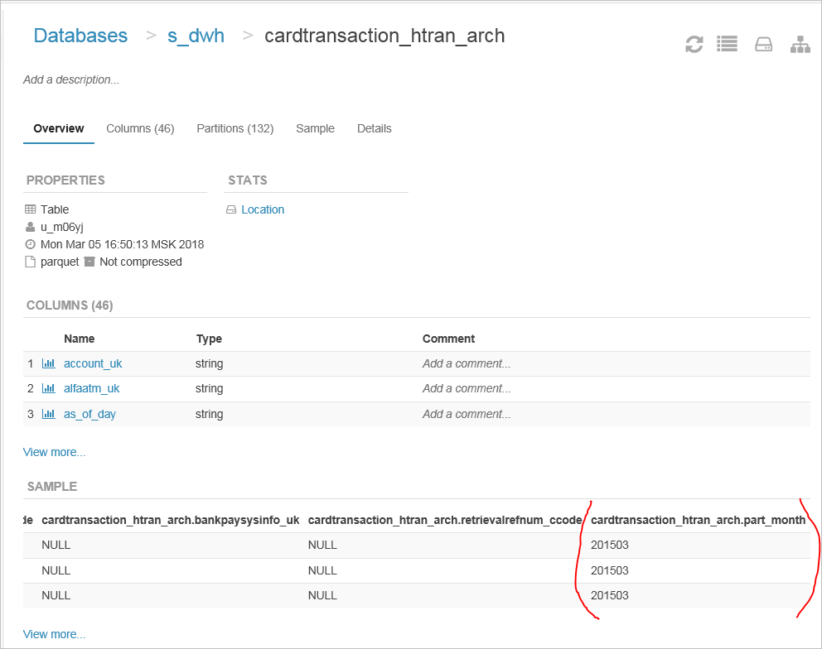

Таблица **cardtransaction_htran** партиционирована по дням:

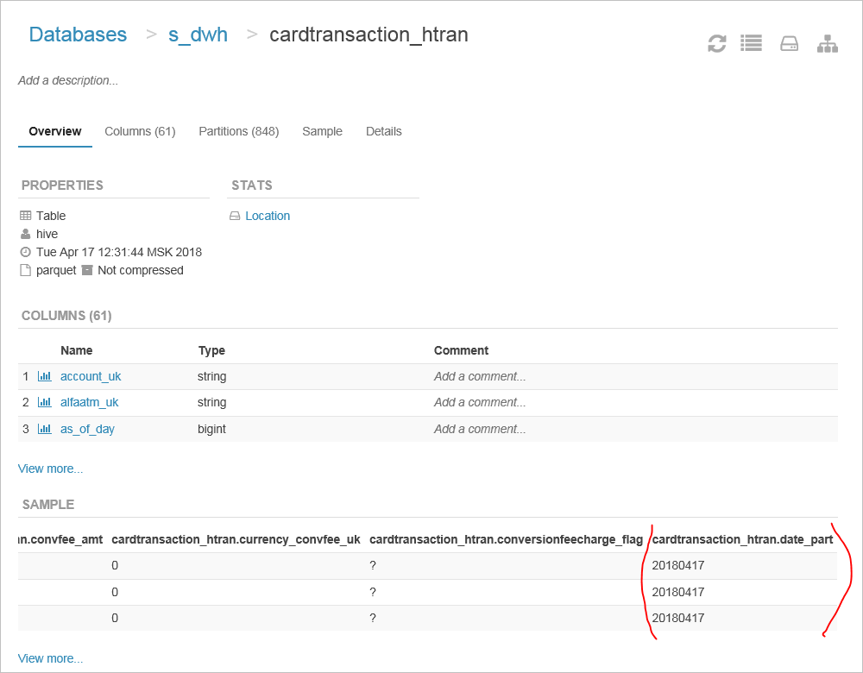

Чтобы получить названия партиций используем **value_day**

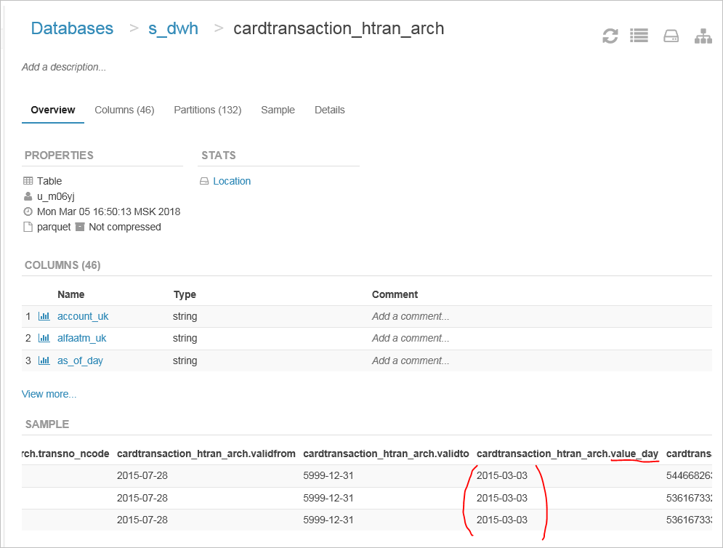

преобразуем его в **date_part:**

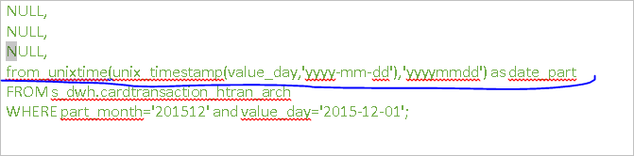

И используем в качестве названия для дигамическисоздаваемых партиций:

